

**SENSORS AND**

**AUTOMATION**

**Sarvesh Anand Mankar**

**142203013**

**SY Comp Div-2, S5 Batch**

**Practical-1: Characterization of RTD**

**Aim:**

1. Study static and dynamic characteristics of RTD
2. Study effect of various parameters on RTD performance

**Theory:**

**RTD:**

A resistance temperature detector (RTD) is a type of temperature sensor that measures temperature by the change in electrical resistance of a metal wire as it is heated or cooled. The most common metal used in RTDs is platinum, although other metals such as nickel and copper can also be used.

RTDs have several advantages over other types of temperature sensors, including high accuracy, stability, and repeatability. They are also relatively easy to use and do not require any calibration or special circuitry.

**Temperature:**

Temperature is a measure of the average heat or thermal energy of the particles in a substance. Since it is an average measurement, it does not depend on the number of particles in an object. In that sense it does not depend on the size of it. For example, the temperature of a small cup of boiling water is the same as the temperature of a large pot of boiling water. Even if the large pot is much bigger than the cup and has millions and millions more water molecules. The basic unit of temperature (T) in the International System of Units (SI) is the Kelvin (K). The commonly used other units of temperature are Degree Celsius (°C) and Degree Fahrenheit (°F).

**Electrical Resistance:**

The electrical resistance of an object is a measure of its opposition to the flow of an electric current. For a wide range of materials and conditions, the electrical resistance does not depend on the amount of current through or the potential difference (voltage) across the object. That means the resistance R is constants for the given temperature and material. Therefore, the resistance of an object can be defined as the ratio of voltage to current, in accordance with

Ohm’s Law: R = V/I ohm

**Temperature calculations:**

RTDs are manufactured from metals whose resistance increases with temperature. Within a limited temperature range, its resistance increases linearly with temperature: Rt = R0[1+ α (t-t0)]

Where: Rt = resistance at temperature 't'

R0 = resistance at a reference temperature ( Generally 0 degree C)

α = temperature coefficient of resistance (°C‾1)

Setting t0 to 0°C and rearranging to the standard linear y = m*x+b form, it is clear that resistance vs. temperature is linear with a slope equal to

R / R0 = α*t + 1

The relationship between resistance and temperature of RTD can be approximated by the Callendar-Van Dusen equation which is given by,

Rt / R0 = 1+ α [ t – δ((t/100)-1)(t/100) –β((t/100)-1)(t/100)3]

Where,

t = temperature (°C)

Rt = Resistance at temperature, t°C

R0 = Resistance at 0°C

α = Constant ( 0.00385Ω/Ω/°C )

δ & β are Linearization coefficients, where β = 0 for t > 0°C

**Pretest:**



**Selected Values:**

1. Material: Platinum
2. Resistance (R0) :100
3. Measurement Temperature :621
4. Your Answer :339.085
5. Measurement Temperature :749
6. Your Answer :388.365
7. Measurement Temperature :323
8. Your Answer :224.35

**Level 1:**

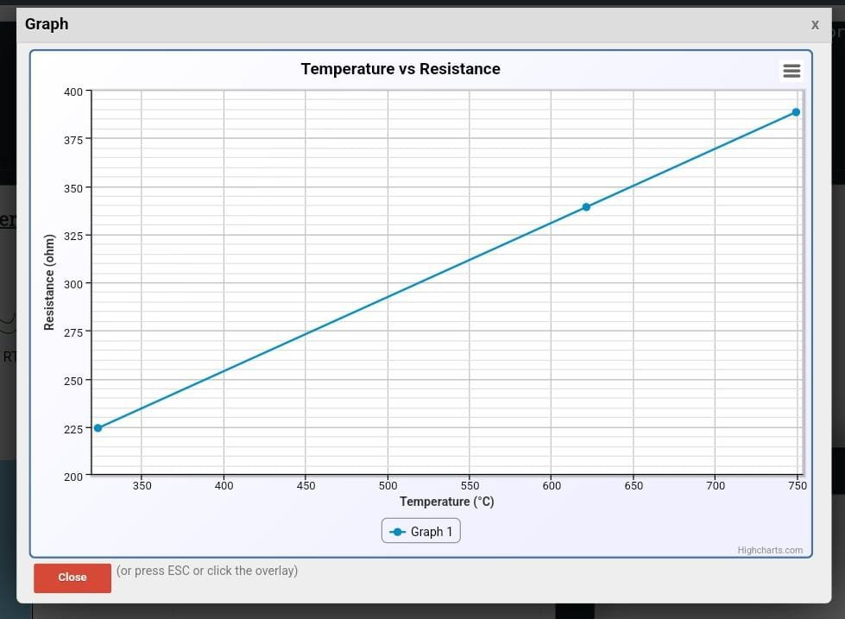

**Level-2:**

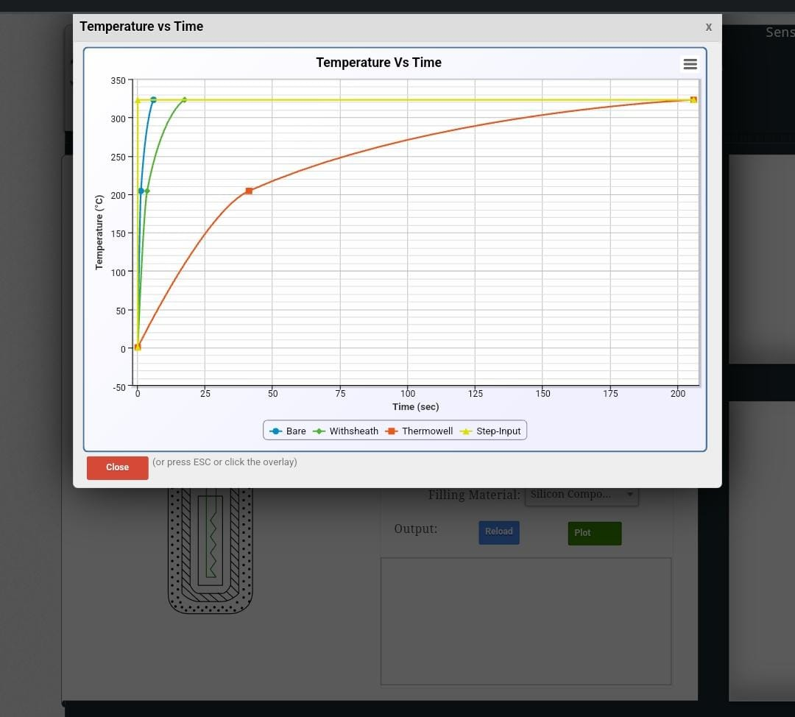

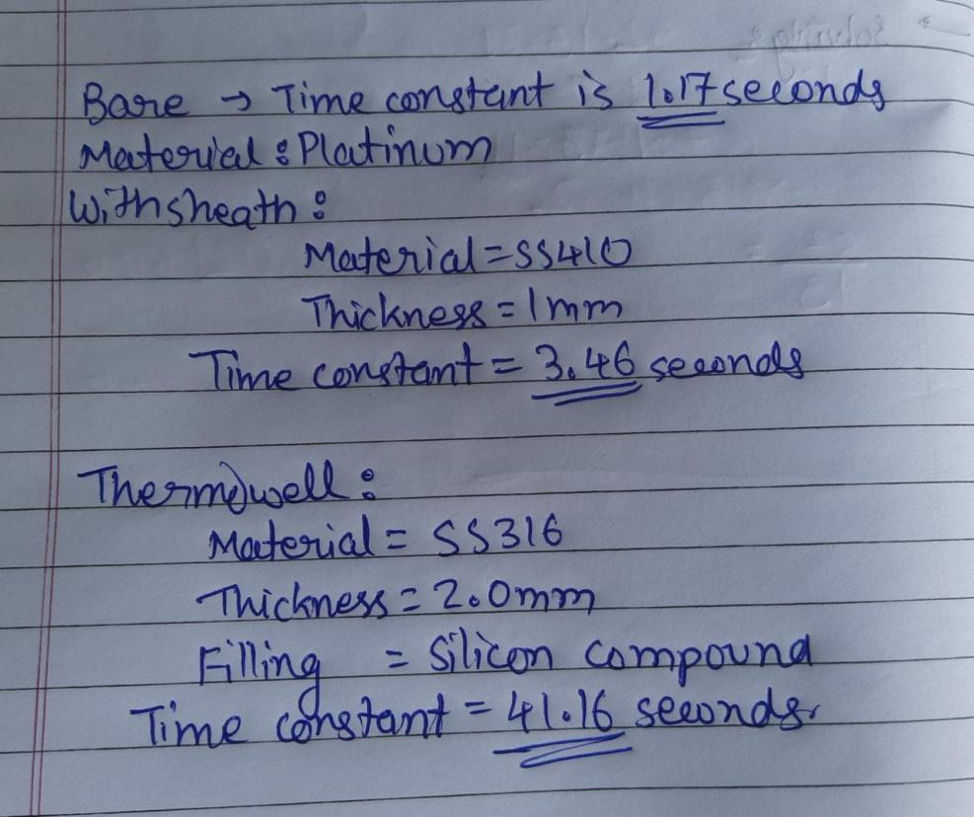

**Selected Values:**

1. Material: Nickel
2. Resistance (R0): 300
3. Measurement Temperature: 44
4. Your Answer: 681.024
5. Measurement Temperature: 205
6. Your Answer: 713.28

**Level 1:**

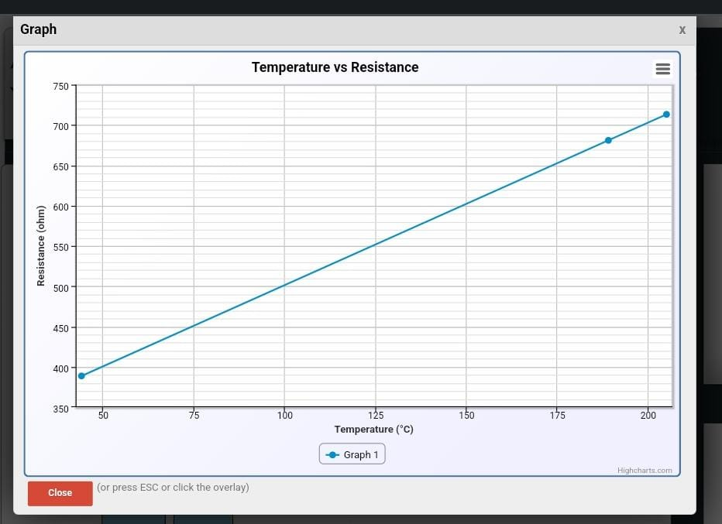

**Level 2:**

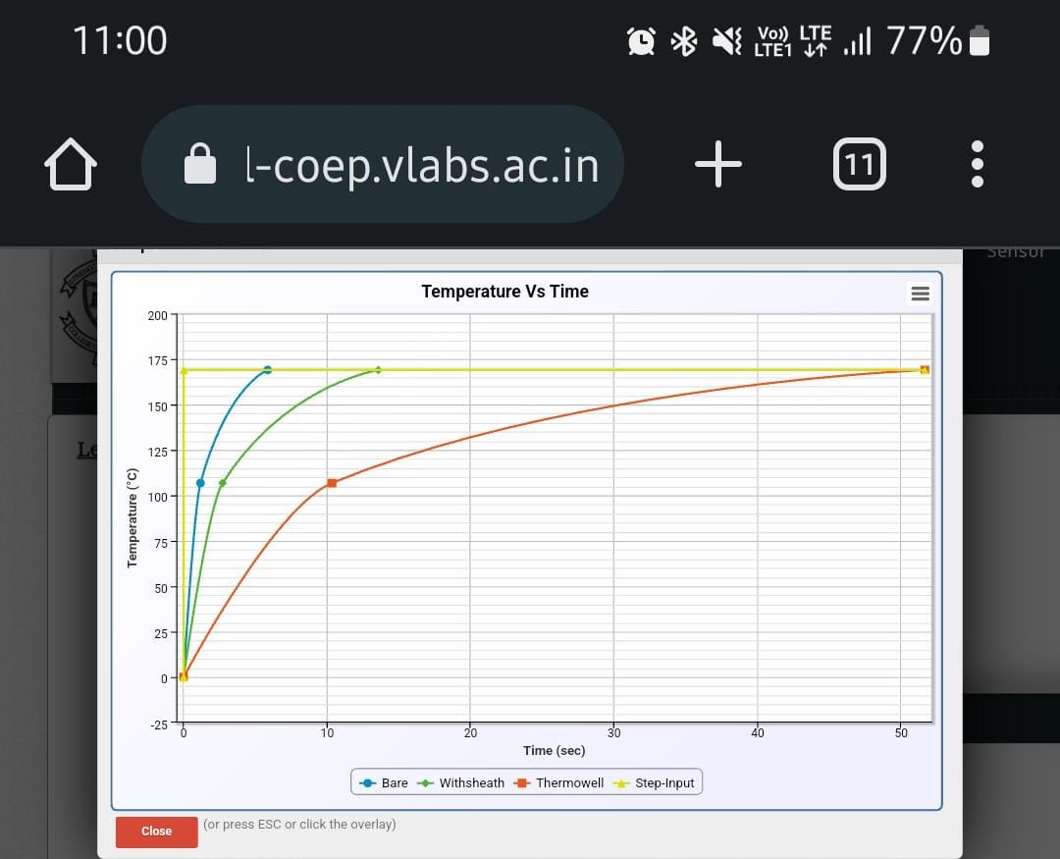

**Posttest:**



**Conlusion:**

We studied characteristics of RTD and effects of various parameters on RTD performance are verified.